Description:
The robot will be able to find an object in a small area (e.g., Workbench) and bring it back to you. You will be able to show the robot what object you want it to go and find, it will then go and find the object and bring it back to you via face recognition. The gesture controls will be used to tell the robot to forget an old object or face and learn a new one.
Features:
Features include Object Identification, Face Recognition, Object Retrieval, Gesture Controlled and Object Avoidance. Additional features may be added as the project progresses
Concept Design:
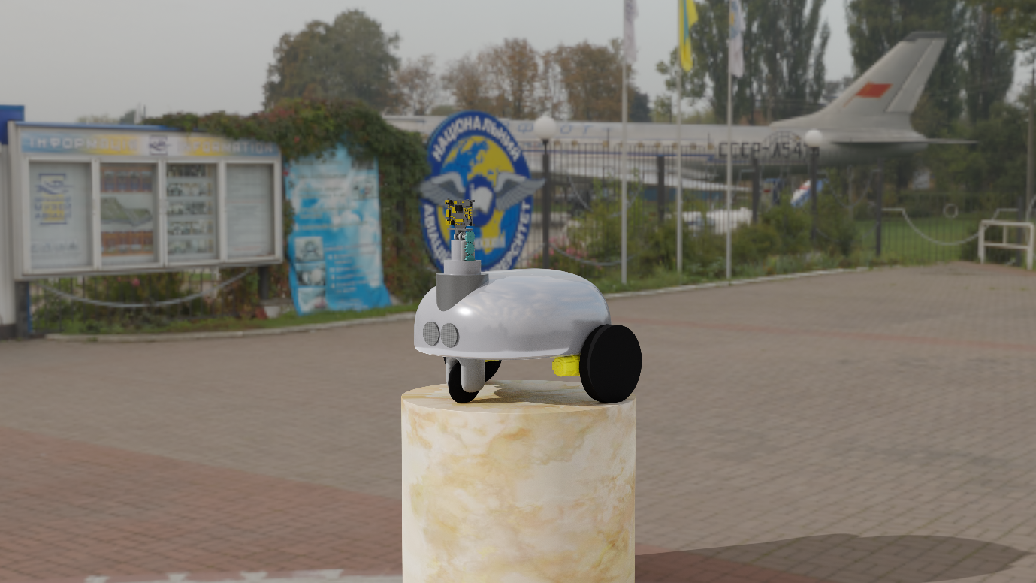
This is merely a concept and may not resemble the final product. Designed in Blender.
Components:
The following components will be used in my project unless I find a suitable substitute for their function:
- HuskyLens (AI Camera)
- Gesture Sensor (APDS9960)
- 3 x Servo
- 2 x TT Motors
- Arduino Nano or Arduino Uno (dependant on circuit design)
- 3d Printed Body (electroplated in parts for aesthetic purposes)
- 2 x Ultrasonic range finder (for object detection and floor detection)
- Jumper wires

